# UCS310

**Database Management System Project**

DOG DAY-CARE

**Submitted By**:

| DRISHTI SHARMA | 102215342 |
| --- | --- |
|  |  |
|  |  |
|  |  |

**Submitted To**:



**Index**

| Sr.No. | Contents | Page No. |
| --- | --- | --- |
| 1. | Introduction | 3 |
| 2. | ER Diagram | 4 |
| 3. | FD and Normalization | 6 |
| 4. | Table Creation | 11 |
| 5. | Table Insertion | 14 |
| 6. | PL-SQL Procedure | 17 |
| 7. | PL-SQL Triggers | 20 |
| 8. | Conclusion | 22 |

# Introduction

"Dog Daycare Database" is a comprehensive project designed to streamline the operations and

Management of a dog daycare facility. This project leverages the power of database technology

to provide a robust and user-friendly solution tailored specifically for the needs of dog daycare

businesses.

At its core, the project aims to address the various challenges faced by dog daycare owners and

operators, ranging from managing client information to tracking daily activities and all the

appointments. By centralizing data and automating routine tasks, the Dog Daycare Database

enhances efficiency, organization and overall service quality.

The project encompasses a wide range of features and functionalities to cater to the diverse

needs of dog daycare facilities. One of its key components is the client management system,

which allows users to store and access vital information about dog owners and their furry

companions. This includes details such as contact information, medical history, vaccination

records, and special requirements.

In addition to client management, the Dog Daycare Database offers tools for scheduling and

appointment management. Users can easily schedule daycare sessions, boarding stays, grooming

appointments, and other services, while also keeping track of availability and capacity. Automated

reminders and notifications help ensure that both staff and clients stay informed and organized.

Furthermore, the project includes modules for tracking daily activities and monitoring dog behavior.

Staff members can record feeding schedules, exercise routines, medication administration, and any

noteworthy incidents or observations. This not only helps maintain a high standard of care but also

provides valuable insights for client communication and reporting.

The Dog Daycare Database is designed to be highly customizable and scalable, allowing users to tailor

the system to their specific requirements and preferences. Whether managing a small boutique daycare

or a large-scale facility, this project provides the tools and resources needed to optimize operations,

streamline workflows, and deliver exceptional service to both human and canine clients alike.

# Data Model

ER Diagram:

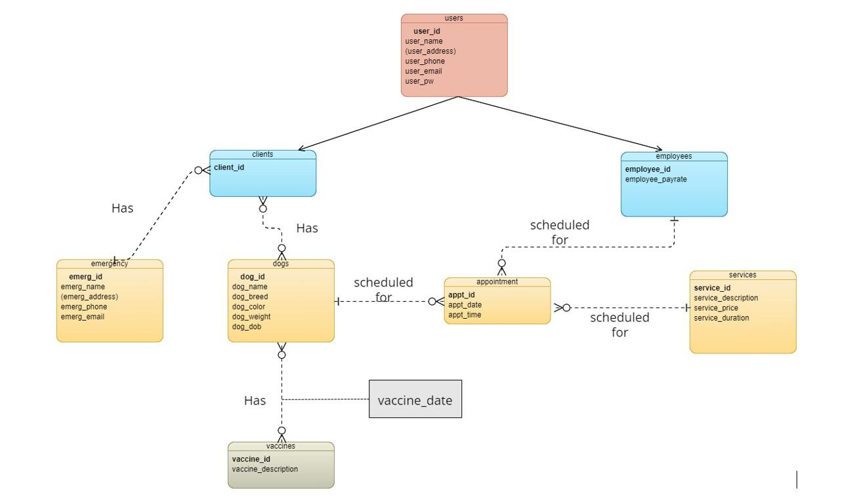

# FD and Normalization

Normalization is the process of minimizing redundancy from a relation or set of relations. Redundancy in relation may cause insertion, deletion, and update anomalies. So, it helps to minimize the redundancy in relations. Normal forms are used to eliminate or reduce redundancy in database tables.

1. **First Normal Form:**

If a relation contains multi-valued attribute, then it violates first normal form or a relation is in first normal form if it does not contain any multi-valued attribute. A relation is in first normal form if every attribute in that relation is singled valued attribute.

1. **Second Normal Form:**

To be in second normal form, a relation must be in first normal form and relation must not contain any partial dependency. A relation is in 2NF if it has No Partial Dependency, i.e., no non-prime attribute (attributes which are not part of any candidate key) is dependent on any proper subset of any candidate key of the table. Partial Dependency – If the proper subset of candidate key determines non-prime attribute, it is called partial dependency.

1. **Third Normal Form:**

A relation will be in 3NF if it is in 2NF and does not contain any transitive partial dependency.

3NF is used to reduce the data duplication. It is also used to achieve data integrity.

If there is no transitive dependency for non-prime attributes, then the relation must be in third normal form.

A relation is in third normal form if it holds at least one of the following conditions for every non-trivial functional dependency X → Y.

X is a super key.

Y is a prime attribute, i.e., each element of Y is part of some candidate key.

## Table Creation & Insertion

**USERS**

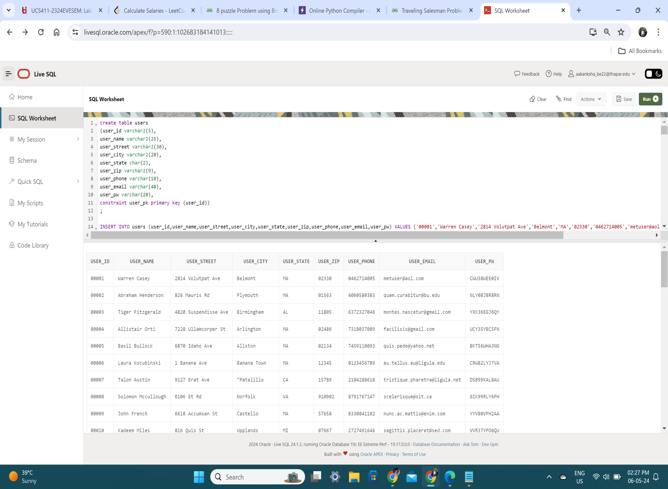

**EMPLOYEES**

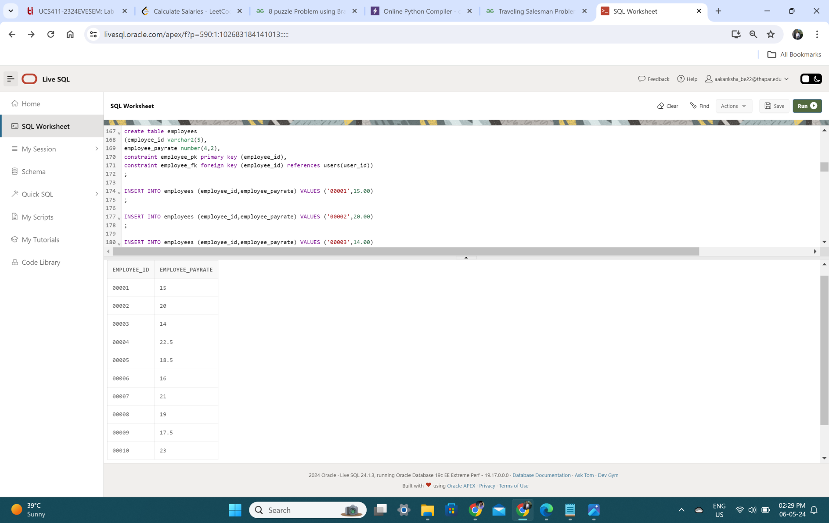

**EMERGENCY**

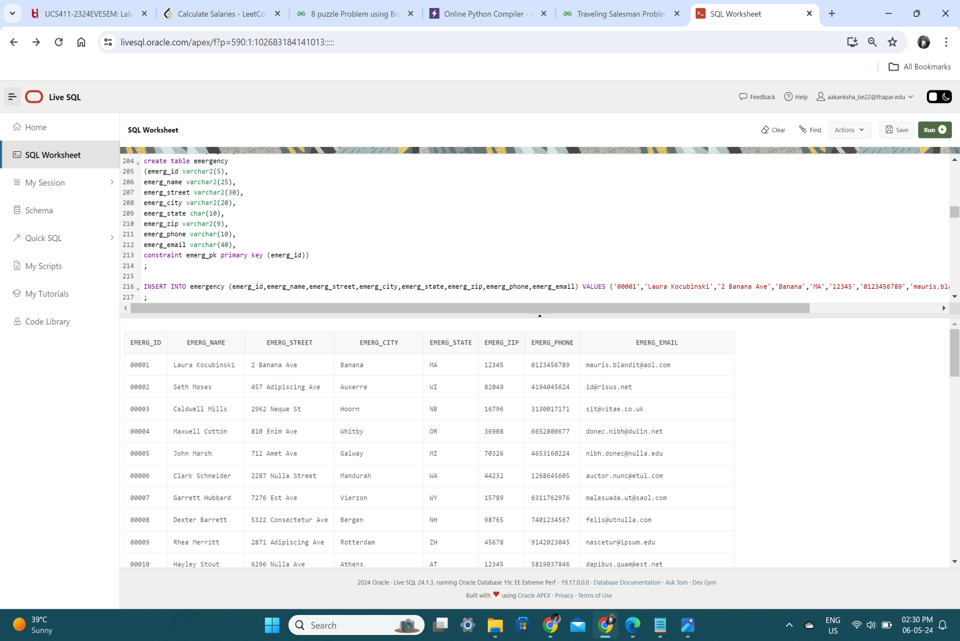

**CLIENTS**

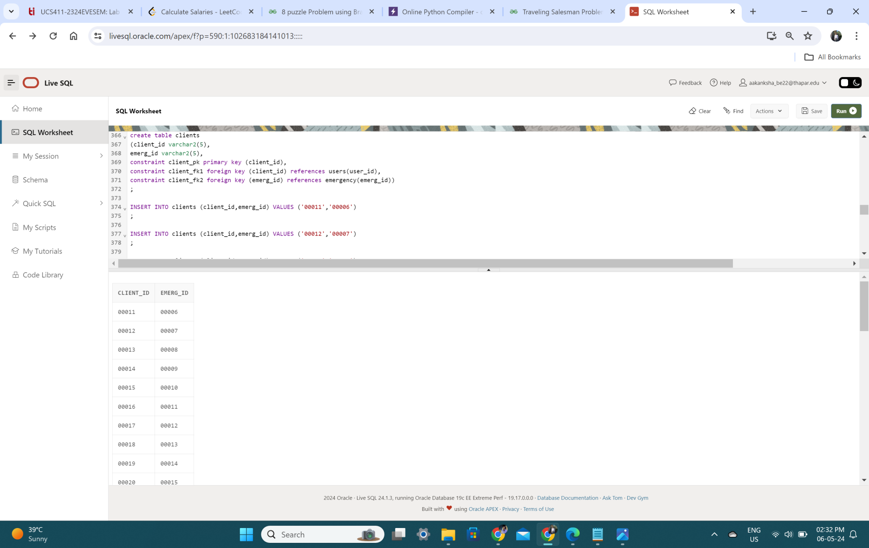

**DOGS**

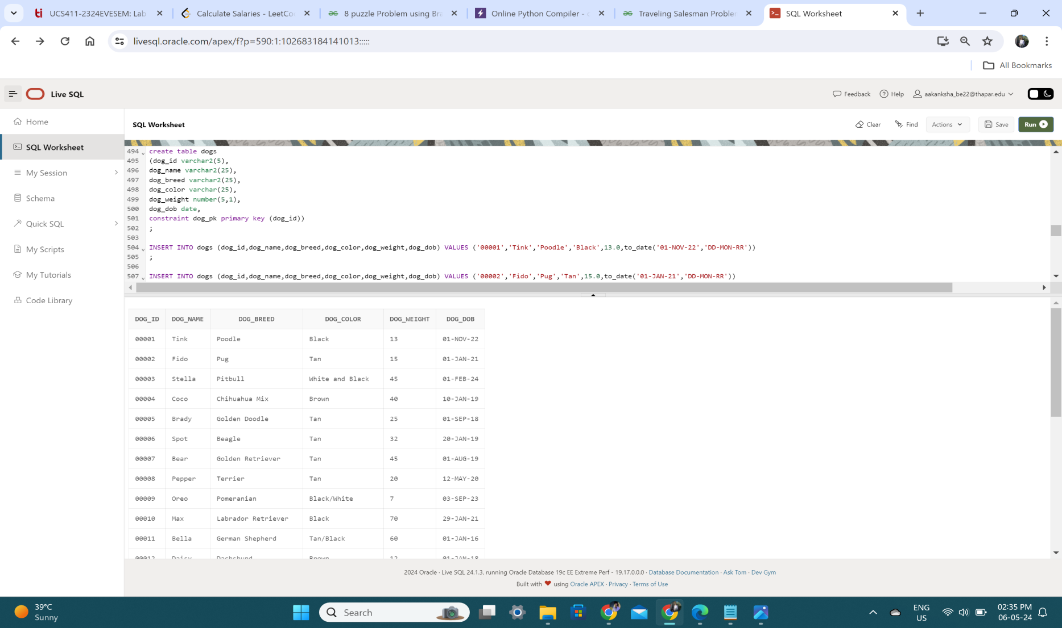

**CLIENT_DOG**

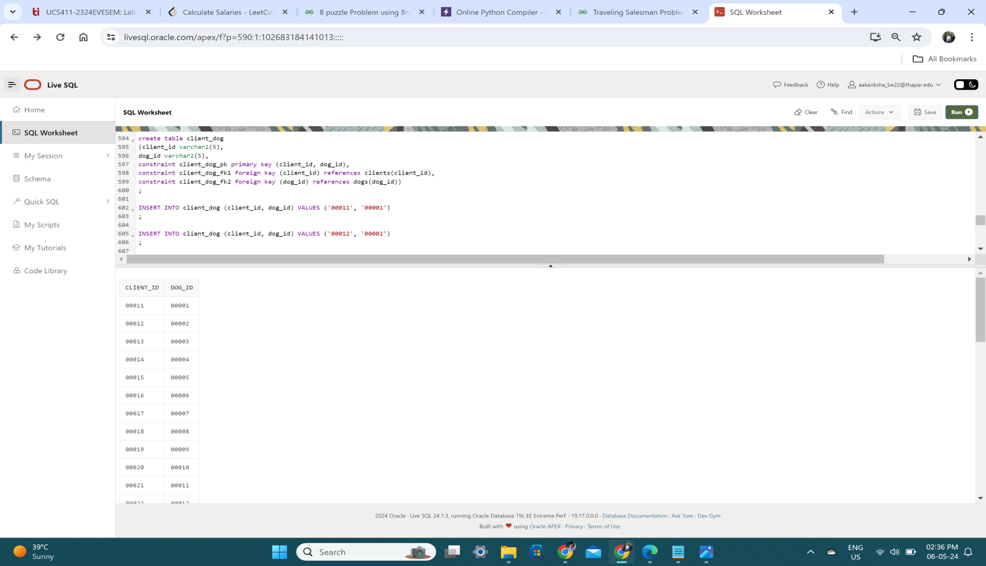

**SERVICES**

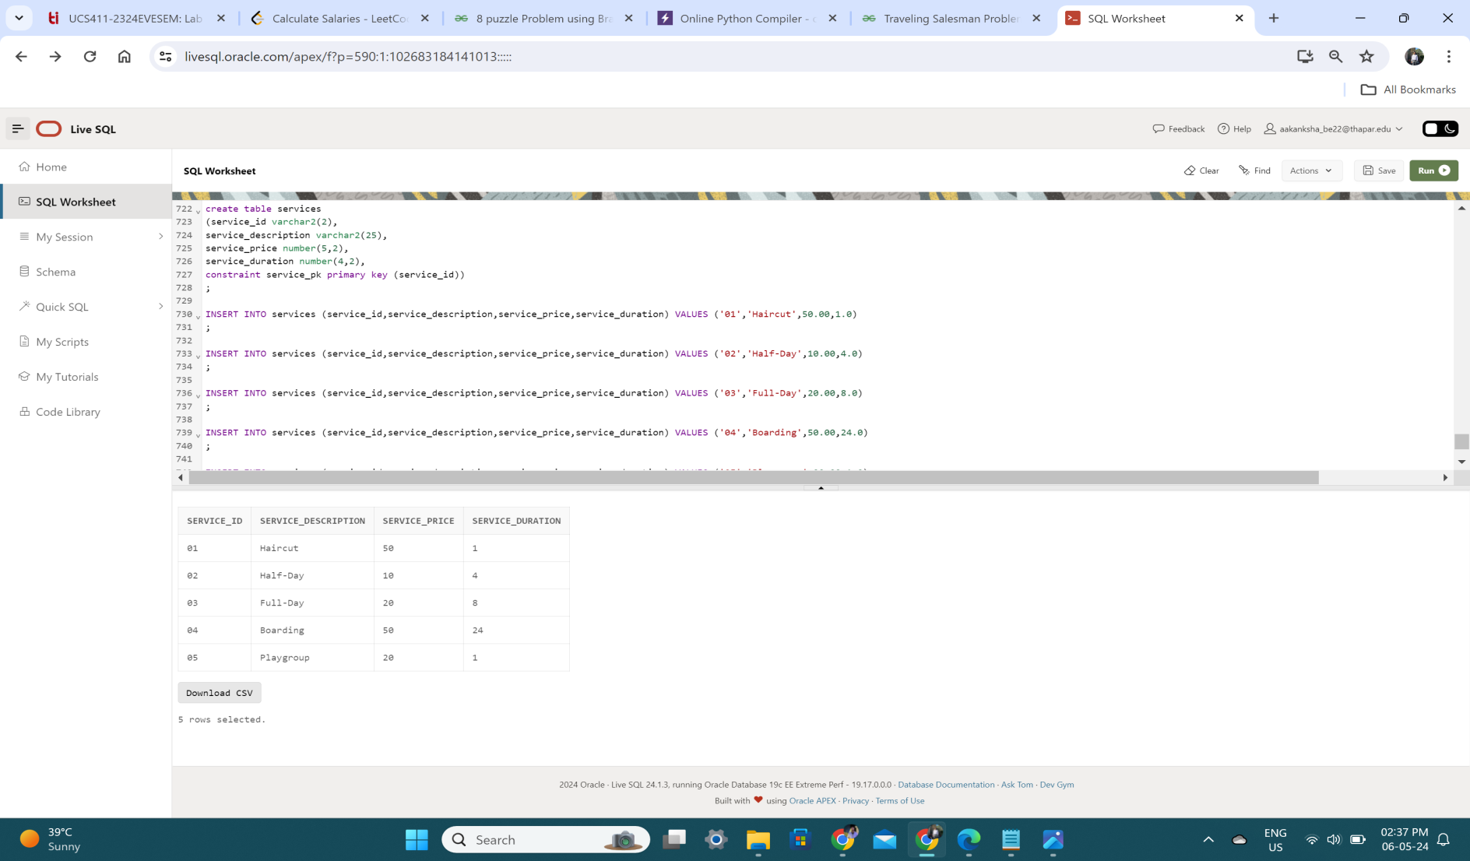

**Appointment**

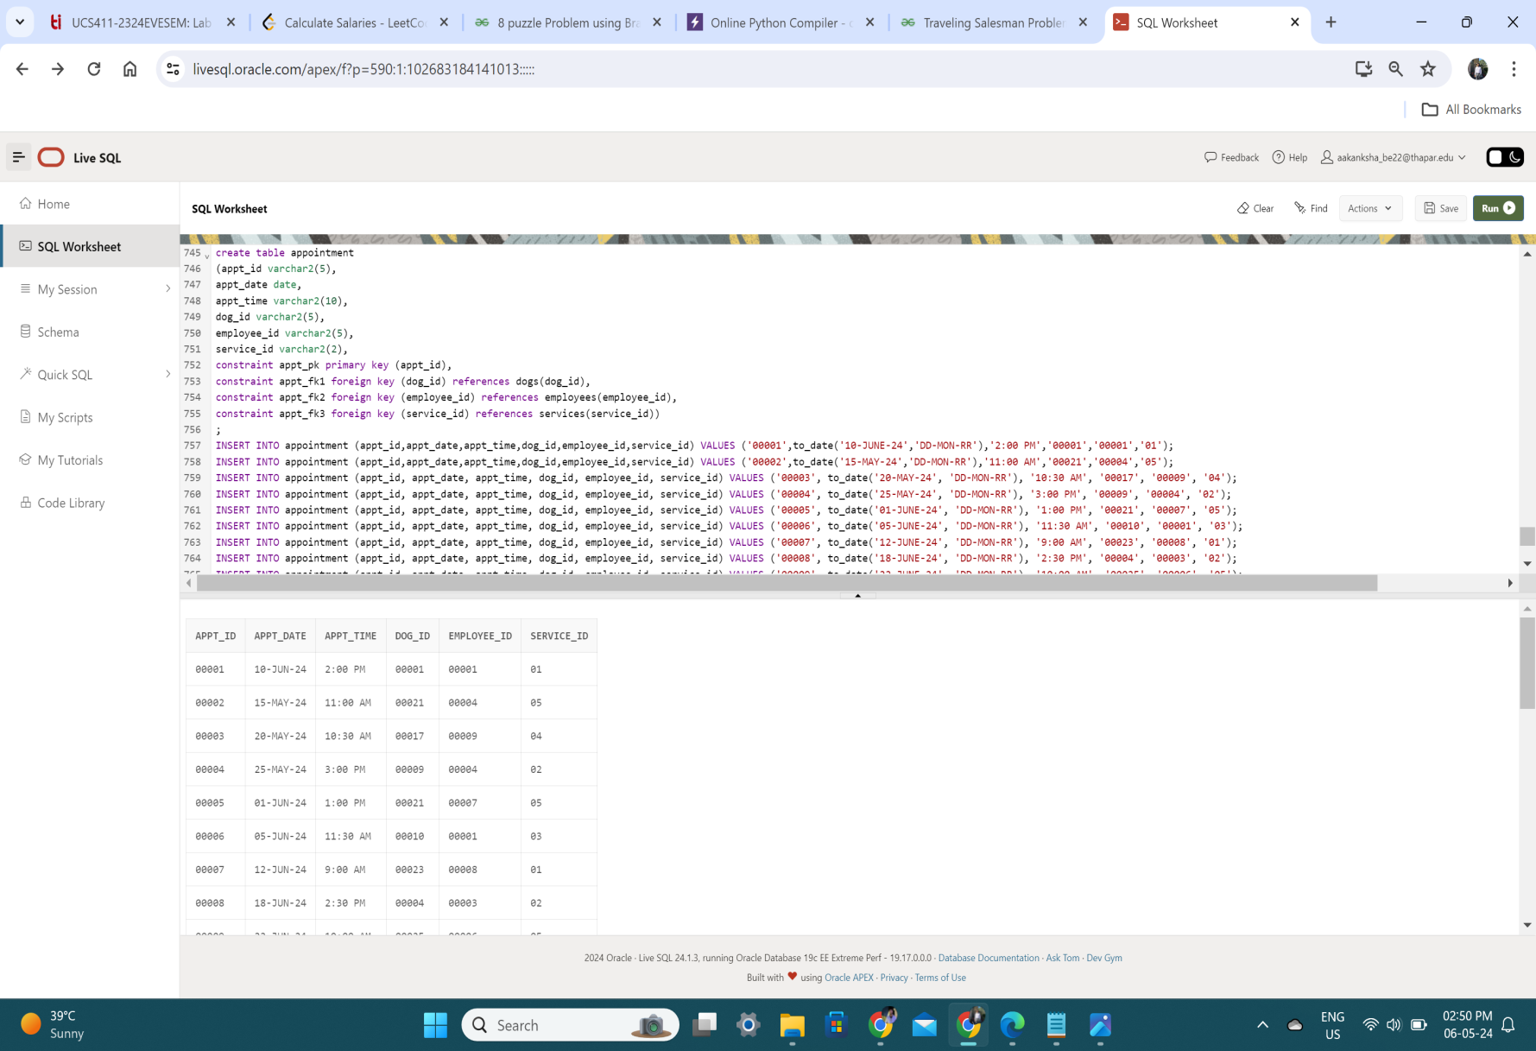

Vaccination

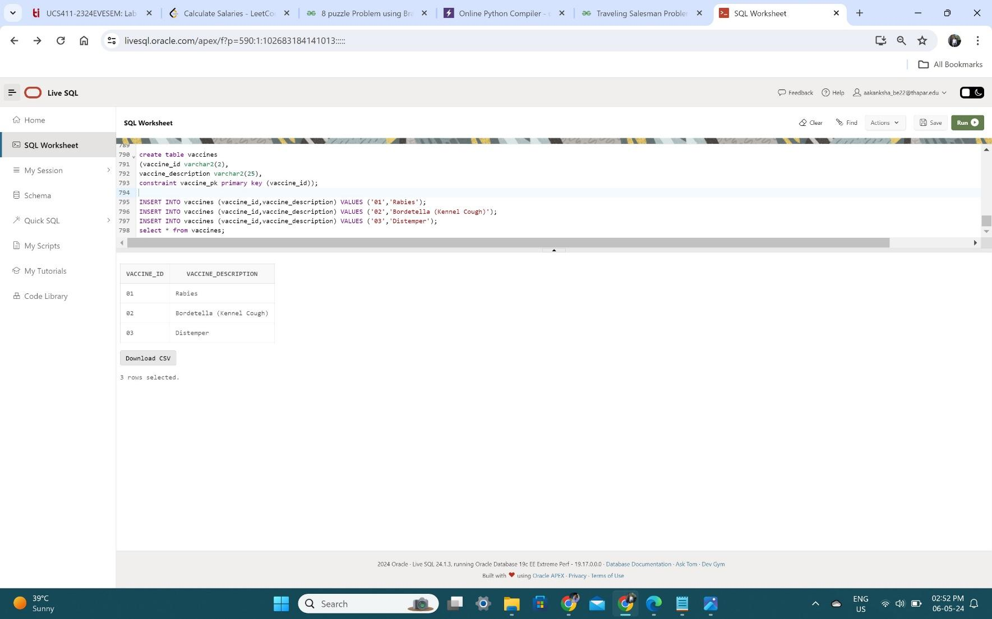

Dog_Vaccination

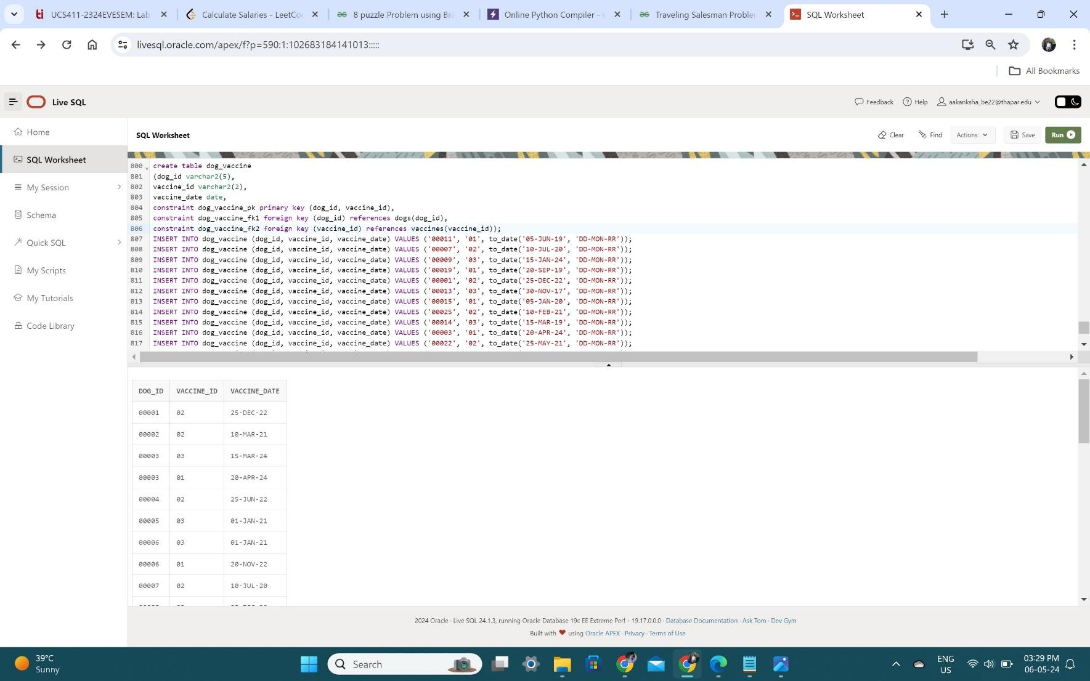

**SQL & PL/SQL Procedures**

The PL/SQL stored procedure or simply a procedure is a PL/SQL block which performs one or more specific tasks. It is just like procedures in other programming languages.

The procedure contains a header and a body.

* Header: The header contains the name of the procedure and the parameters or variables passed to the procedure.
* Body: The body contains a declaration section, execution section and exception section similar to a general PL/SQL block.

**Return Dogs & Their Owners**

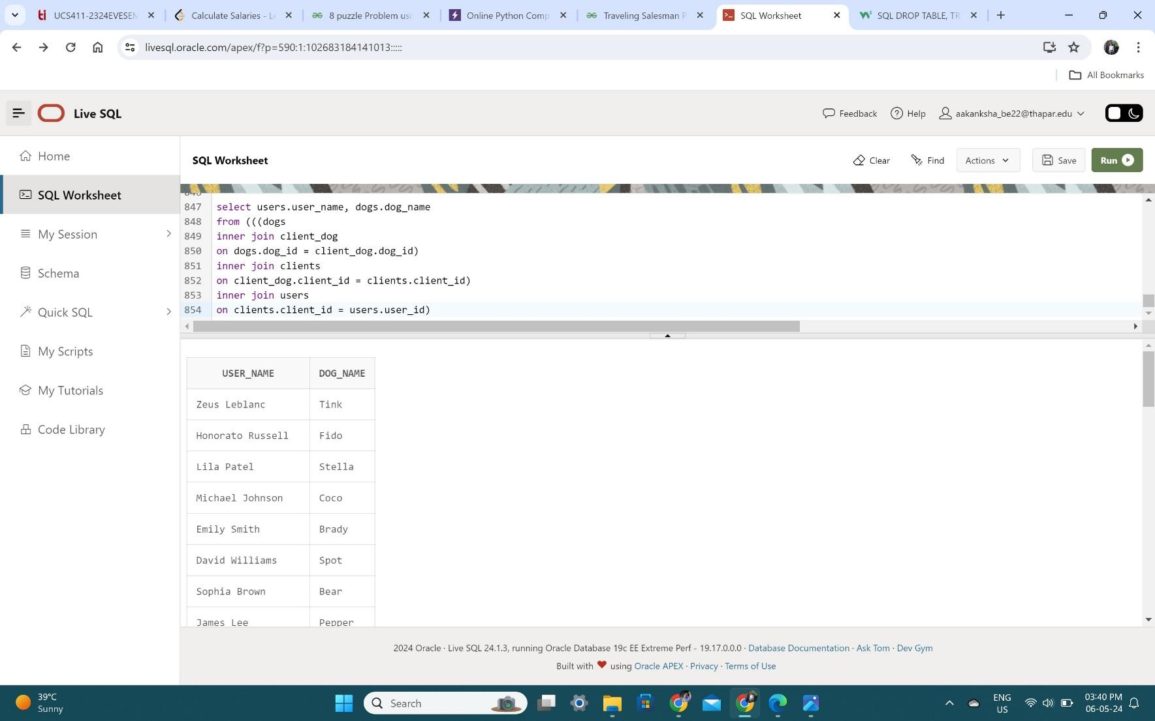

**Show all Appointments**

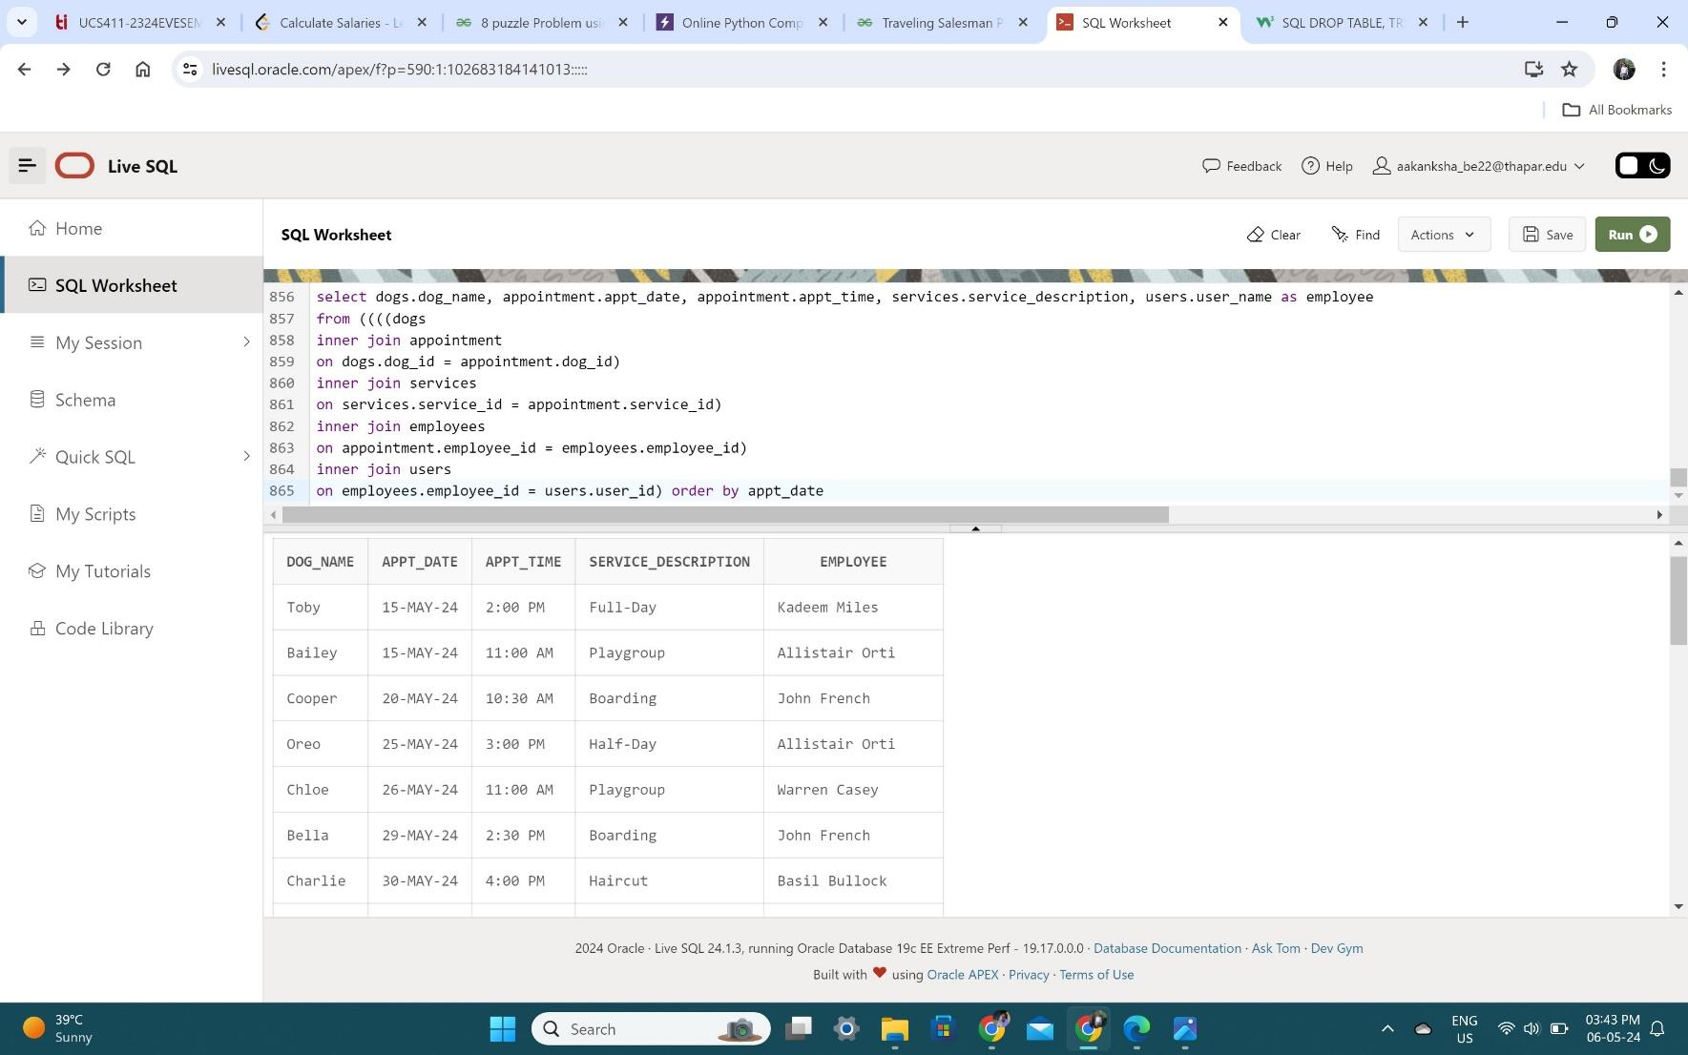

**Show Vaccines for Dog ‘Spot’**

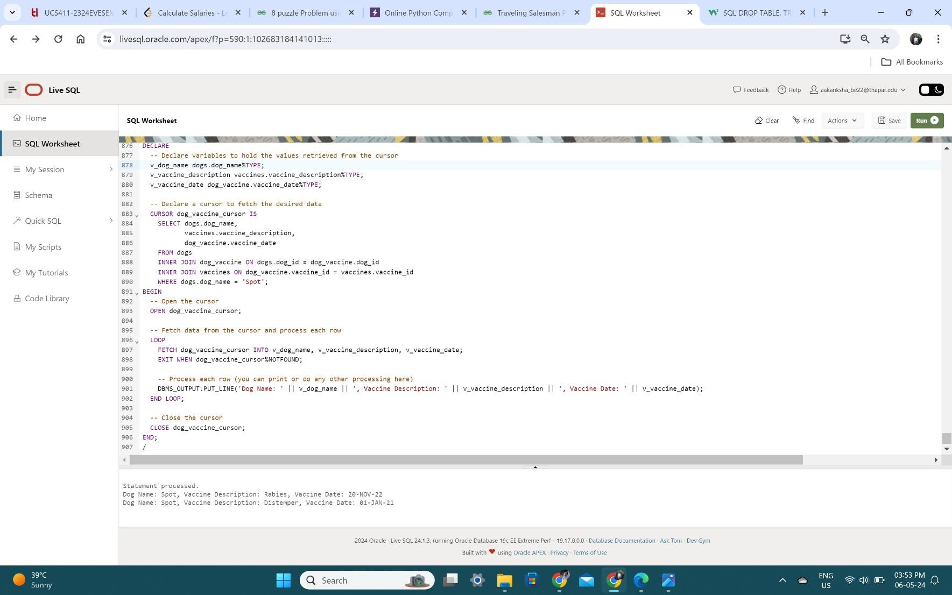

Return Name of Dogs aged less than 2

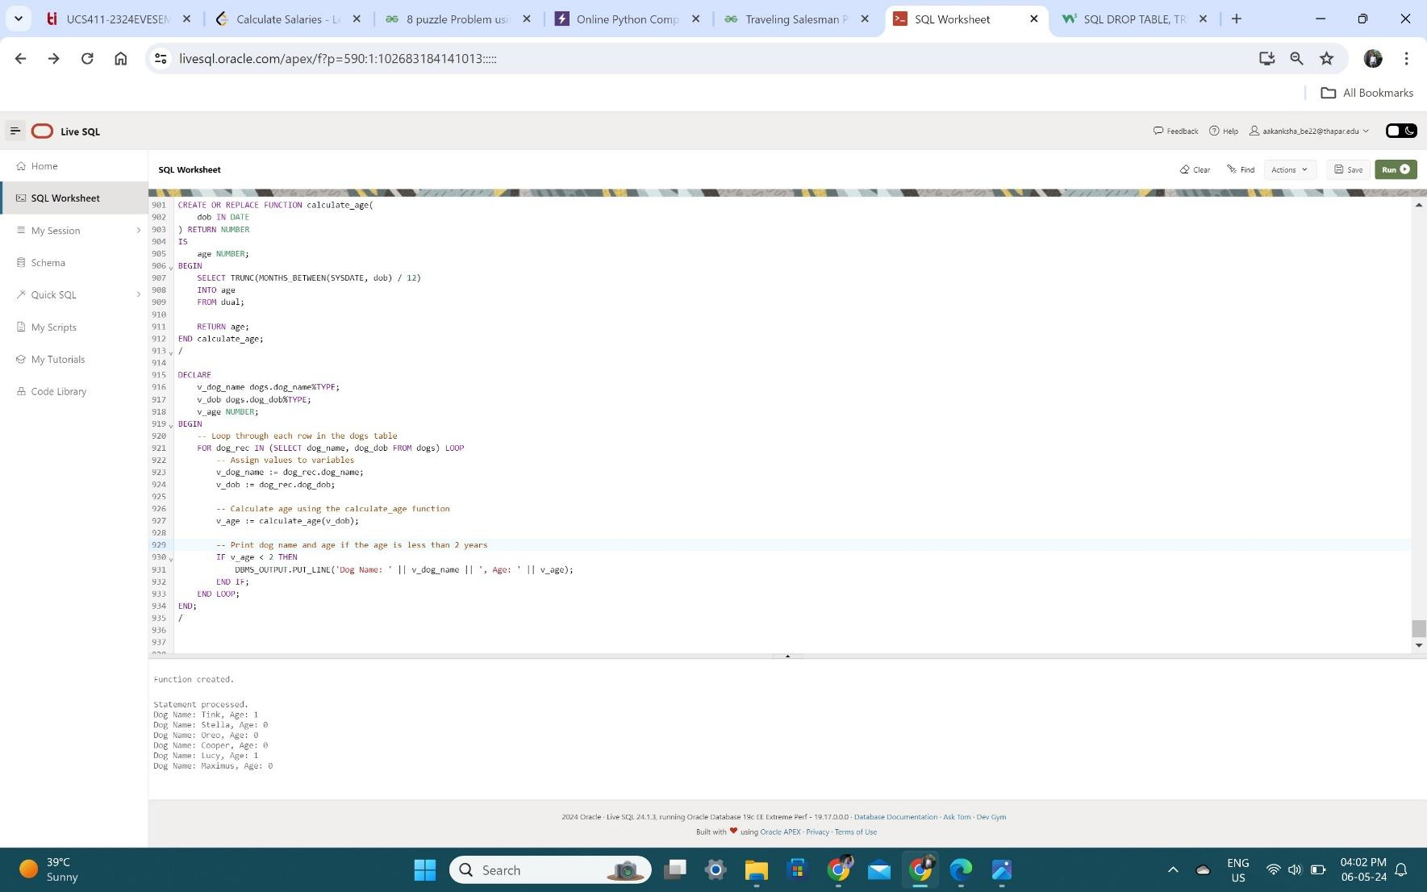

## PL/SQL Trigger

Trigger is invoked by Oracle engine automatically whenever a specified event occurs.Trigger is stored into database and invoked repeatedly, when specific condition match.

Triggers are stored programs, which are automatically executed or fired when some event occurs. Triggers are written to be executed in response to any of the following events.

* A database manipulation (DML) statement (DELETE, INSERT, or UPDATE).
* A database definition (DDL) statement (CREATE, ALTER, or DROP).
* A database operation (SERVERERROR, LOGON, LOGOFF, STARTUP, or SHUTDOWN).

Triggers could be defined on the table, view, schema, or database with which the event is associated.

# CONCLUSION

In conclusion, the Dog daycare management system developed using SQL and PL/SQL provides an efficient and effective solution for managing the process of the dog care. Through the use of SQL queries and PL/SQL procedures and triggers, the project has demonstrated the power of these tools in extracting meaningful insights from the data. The dog day care system developed in this project showcases the potential of DBMS and SQL/PLSQL for effective management of complex data-intensive processes.

Overall, the "Dog Daycare Database" project represents a valuable resource for dog daycare businesses seeking to optimize their operations and provide superior care to their furry clientele. By combining robust database functionality with user-friendly design principles, the project sets a high standard for efficiency, reliability, and customer satisfaction in the industry. Whether managing appointments, tracking payments, or analyzing trends, this comprehensive solution empowers daycare operators to focus on what they do best: creating a safe and enjoyable environment for dogs to thrive.